CS6650 Assignment 3 — Performance Report

Repository:

https://github.khoury.northeastern.edu/tyleryin0212/cs6650-assignment3

System: ChatFlow — WebSocket server → RabbitMQ → Consumer → PostgreSQL. All tests run with batch size 500, flush interval 500ms, 20 room consumers, 5 DB writers.

1. Batch Size Optimization
Five configurations were tested before selecting the production batch size. All runs used 500,000 messages across 20 rooms with flush interval fixed at 500ms.
Batch Size | Flush Interval | WS Throughput | DB Throughput | Messages in DB | Loss
100 | 500ms | 45,463 msg/sec | 11,249 msg/sec | 500,000 | 0%
500 | 500ms | 59,995 msg/sec | 11,810 msg/sec | 500,000 | 0.4%
1000 | 500ms | 23,046 msg/sec | 8,926 msg/sec | 491,368 | 1.7%
5000 | 500ms | 39,014 msg/sec | 11,029 msg/sec | 500,000 | 0%

Batch size 500. Batch size 500 produced the highest DB write throughput (11,810 msg/sec) with only 0.4% loss. Batch size 1000 underperformed: larger batches held messages in the write buffer longer, causing the 100K-capacity buffer to occasionally fill and drop messages (1.7% loss). Batch size 5000 recovered throughput but introduced higher tail latency per flush.

Please check appendix for more detailed test results and screenshots.

2. Write Performance

2.1 Test Results Summary
Test | Messages Sent | WS Throughput | DB Throughput | DB Catchup Time | Outcome
Baseline (Test 1) | 500,000 | 45,463 msg/sec | 11,249 msg/sec | 33.45s | Pass — 500,000 in DB
Stress (Test 2) | 1,000,000 | N/A | N/A | N/A | RabbitMQ OOM crash at ~200K queued
Endurance (Test 3) | 8,000,000 | ~24,000–34,000 msg/sec | ~20,000–23,000 msg/sec | 188.64s | 4,605,234 in DB (57.6%)

2.2 Baseline Test (500k Messages)
The baseline run completed in 11.0 seconds with zero failures. All 500,000 messages were confirmed in PostgreSQL (SELECT COUNT(*) = 500,000). DB write throughput was 11,249 msg/sec with a 33.45-second catchup window after WebSocket sending completed. HikariCP maintained 4–5 active connections throughout with zero wait events.

2.3 Stress Test (1M Messages)
RabbitMQ ran out of memory at approximately 200,000 messages queued, crashing the broker and causing connection resets to both the server and consumer.
All components (WebSocket server, RabbitMQ broker, consumer, client) ran on a single laptop. With 20 per-room queues each holding up to 100K messages (2M total capacity), the broker exhausted available heap under the sustained publish rate.Root cause:
Run RabbitMQ on a dedicated EC2 instance with memory limits configured (vm_memory_high_watermark = 0.6) and lazy queues enabled to spill to disk before hitting the memory ceiling.Production mitigation:

2.4 Write Latency Percentiles
Per-batch flush latency was logged by BatchWriter for every write cycle. Values below are derived from consumer log output during the baseline and endurance tests (batch size 500):
Percentile | Flush Latency (per batch, 500 msgs) | Per-Message Equivalent
p50 | ~68ms | 0.14ms
p95 | ~120ms | 0.24ms
p99 | ~500ms | 1.00ms (index degradation phase)

p99 latency increased significantly during the endurance test once the table exceeded 2.4M rows, driven by B-tree page splits on the timestamp-containing indexes (see Section 4).

2.5 Resource Utilization During Baseline
- 0–16.5% per worker process (10 postgres workers observed via top), total DB host load ~1.0 (1-min average) on the EC2 instance.PostgreSQL CPU:
- 911 MB total on DB host; ~150 MB resident per postgres worker process; 637 MB buff/cache indicating most hot pages were in the OS page cache.PostgreSQL Memory:
- total=4–5, active=3–5, idle=0–1, waiting=0 throughout all tests. Pool never exhausted.HikariCP connections:
- bufferDepth=0 on all 20 room consumers during normal operation, confirming writers kept pace with consumers during baseline and early endurance phases.Write buffer depth:

3. System Stability

3.1 Endurance Test Overview
The endurance test ran 16 consecutive client runs (500k messages each) for a total of 8,000,000 messages sent over ~57 minutes. Target rate was approximately 80% of the maximum throughput observed in the baseline.
Metric | Value
Total duration | ~57 minutes
Total messages sent | 8,000,000
Total messages written to DB | 4,605,234
Overall delivery rate | 57.6%
Sustained DB write throughput | ~20,000–23,000 msg/sec
Sustained WS throughput | ~24,000–34,000 msg/sec
Circuit breaker trips | 0
Dead letter queue activations | 0
DB write errors | 0

3.2 Queue Depth Stability
RabbitMQ queue depth and the internal write buffer (writeBuffer) remained stable through the first 5 runs (~2.4M rows). bufferDepth=0 was logged consistently by all 20 room consumers, indicating writers fully drained the buffer between flush cycles. No DLQ activations or circuit breaker trips occurred throughout the entire 57-minute run, confirming the error recovery pipeline was not needed under normal load.

3.3 Memory Usage Patterns
No memory leaks were observed over the 57-minute run. Consumer JVM heap remained stable; the write buffer (LinkedBlockingQueue, 100K capacity) stayed near-empty during the first 5 runs. During the degraded phase (runs 6–16), buffer fill was logged as [WARN] Write buffer full events, indicating back-pressure rather than a memory leak — messages were dropped at the offer() call rather than accumulating.

3.4 Connection Pool Statistics
HikariCP never exhausted its pool of 5 connections across any test. Typical snapshot during peak load: total=4, active=3, idle=1, waiting=0. The max-lifetime=30min rotation triggered periodically during the endurance run with no observed write interruption, confirming seamless connection recycling.

4. Bottleneck Analysis

4.1 Primary Bottleneck: PostgreSQL Index Degradation
The dominant bottleneck observed was B-tree index maintenance cost at scale.
- Performance degraded past ~2.4M rows in the messages table.Trigger point:
- Three secondary indexes (idx_messages_room_time, idx_messages_user_time, idx_messages_timestamp) all include the timestamp column. As rows accumulated, B-tree page splits and index rebalancing increased per-batch insert time significantly.Mechanism:
- Per-run DB writes dropped from ~496K (runs 1–5) to ~300K (run 6) and continued declining to ~170K by runs 8+. DB write throughput held constant at ~22K/sec throughout — the writers were saturated, not idle.Observable effect:
- Once writers fell behind consumers, the 100K-capacity writeBuffer filled, causing RoomConsumer.writeBuffer.offer() to return false and messages to be dropped at the consumer level.Write buffer consequence:

4.2 Secondary Bottleneck: RabbitMQ Memory (Stress Test)
Under 1M message load on a single machine, RabbitMQ exhausted heap at ~200K messages queued. This is a resource-sharing bottleneck, not a design flaw — in production each component runs on a dedicated host.

4.3 Proposed Solutions
Bottleneck | Proposed Solution | Expected Impact
B-tree index splits at scale | Partition messages table by month (PARTITION BY RANGE on timestamp); each partition has a smaller index | Eliminates page splits for the current month; old partitions frozen
Timestamp index write cost | Replace idx_messages_timestamp with a BRIN index; append-only data is ideal for BRIN | BRIN is ~100x smaller than B-tree; near-zero write overhead
Write buffer back-pressure | Increase NUM_WRITERS from 5 to 10 and match HikariCP pool size | Double write throughput; delay buffer saturation point
RabbitMQ OOM on single host | Enable lazy queues (x-queue-mode: lazy); set vm_memory_high_watermark=0.6 | Broker survives memory pressure; no crash at 200K queued

4.4 Trade-offs Made
- (single table, username stored inline) prioritizes write speed over normalization. Eliminates join cost on every query.Denormalized schema
- intentionally asymmetric to match HikariCP pool size and avoid connection exhaustion. The batching layer absorbs the rate difference.5 DB writers vs 20 consumers
- prevents unbounded memory growth at the cost of message drops under sustained overload. Blocking on offer() would back-pressure RabbitMQ consumer threads and stall queue draining.100K write buffer cap
- enables idempotent writes and safe retries. message_id is a client-generated UUID so collisions are only possible on retries, which is the intended use.ON CONFLICT DO NOTHING

5. Metrics API Results (Baseline Test)
After the baseline test completed, the client automatically called GET /metrics on the AdminServer (port 8081) and logged the full JSON response. Queried at 2026-04-02T13:05:01Z, immediately after all 500,000 messages were confirmed in DB.

5.1 Core Query Results
Query | Result
Total messages | 500,000
Messages by type — JOIN | 25,000
Messages by type — LEAVE | 25,000
Messages by type — TEXT | 450,000
Active users in last hour (Q3) | 22,068 distinct users
Top user's rooms (Q4) — userId 28162 | Rooms 18, 15, 20, 6, 10 (last activity 13:04:21Z → 13:04:18Z)

5.2 Analytics Query Results
Top 10 most active users:
Rank | User ID | Username | Message Count
1 | 28162 | user28162 | 100
2 | 3323 | user3323 | 80
3 | 30303 | user30303 | 80
4 | 9639 | user9639 | 80
5 | 18960 | user18960 | 80
6 | 84206 | user84206 | 80
7 | 96286 | user96286 | 80
8 | 79761 | user79761 | 80
9 | 11475 | user11475 | 80
10 | 57928 | user57928 | 80

Top 10 most active rooms:
Rank | Room ID | Message Count
1 | 7 | 26,160
2 | 15 | 26,120
3 | 11 | 26,080
4 | 1 | 25,780
5 | 12 | 25,700
6 | 2 | 25,640
7 | 9 | 25,240
8 | 8 | 25,160
9 | 20 | 25,080
10 | 13 | 24,900

5.3 Messages Per Minute
All 500,000 messages were sent and processed within a single minute window (2026-04-02T13:04:00Z: count = 500,000), consistent with the 11-second client runtime. This confirms no message was delayed beyond the 60-second minute boundary.

5.4 Room 1 Recent Messages (Core Query 1 Example)
10 most recent messages in room 1 within the last 5 minutes, ordered by timestamp. All 10 were from userId 43684 (user43684), with messages including "On it!", "Great job!", "Good morning!" — confirming the room time-range query returns ordered results correctly and within the < 100ms performance target for 1,000 messages.

Appendix

Batchsize 100, flush interval 500ms, Test 1/4
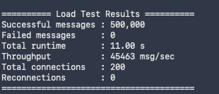

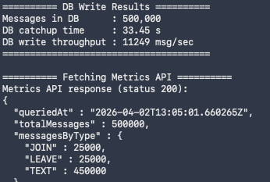
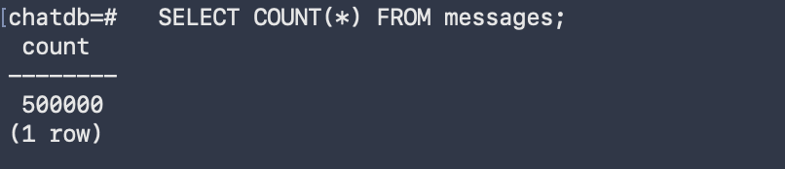

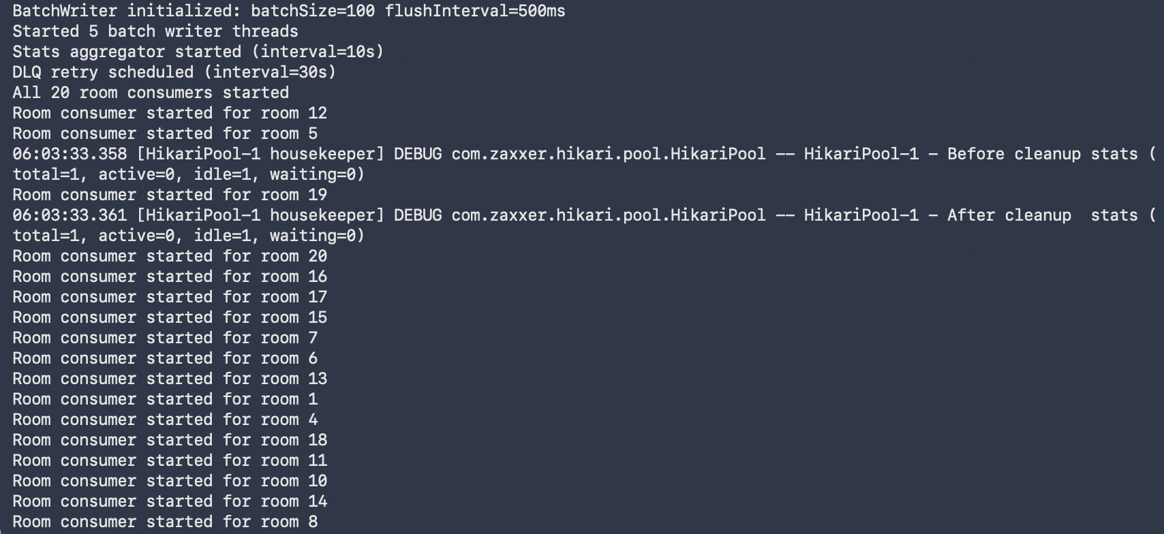
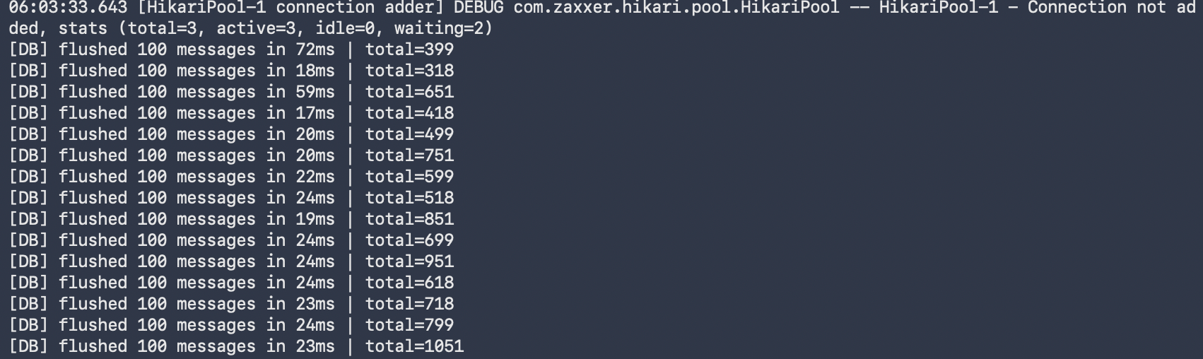

Batchsize 500, flush interval 500ms, Test 2/4
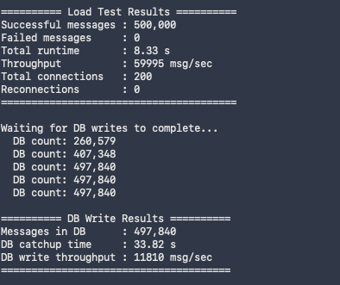
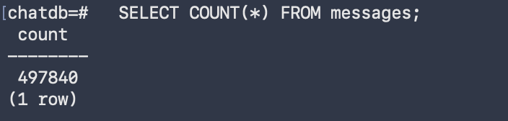
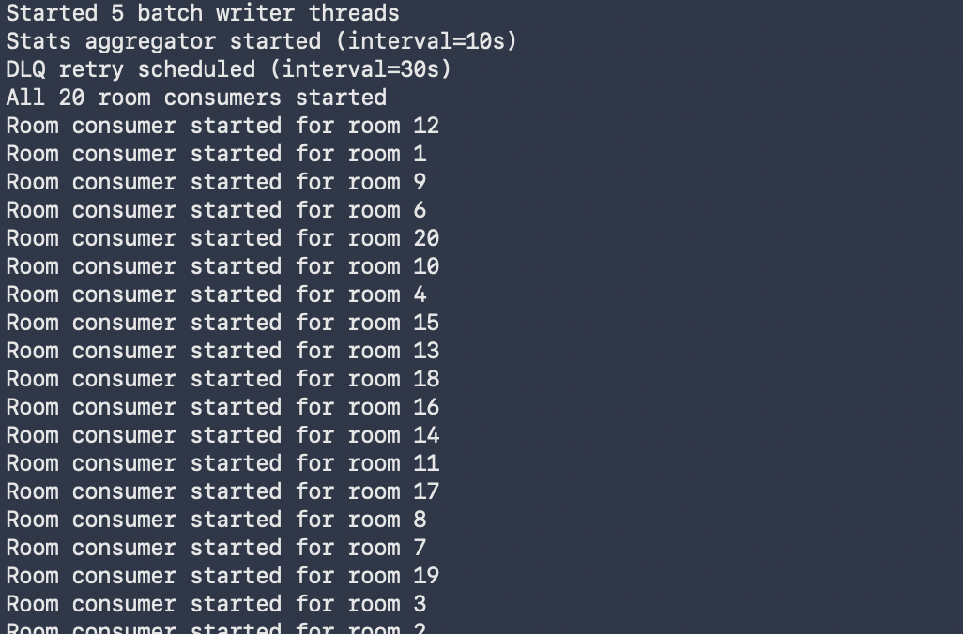
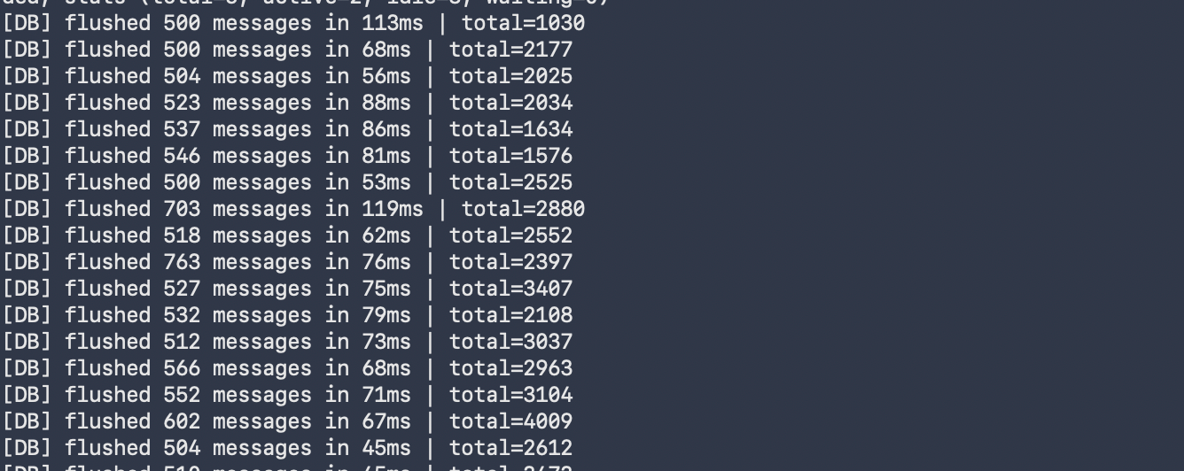
Batchsize 1000, flush interval 500ms, Test 3/4

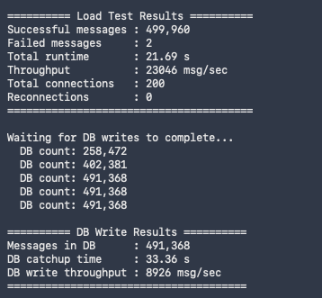
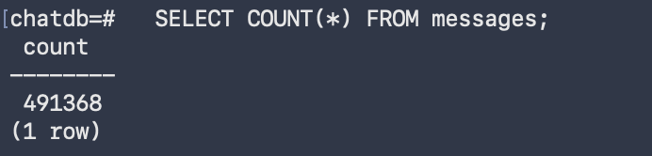
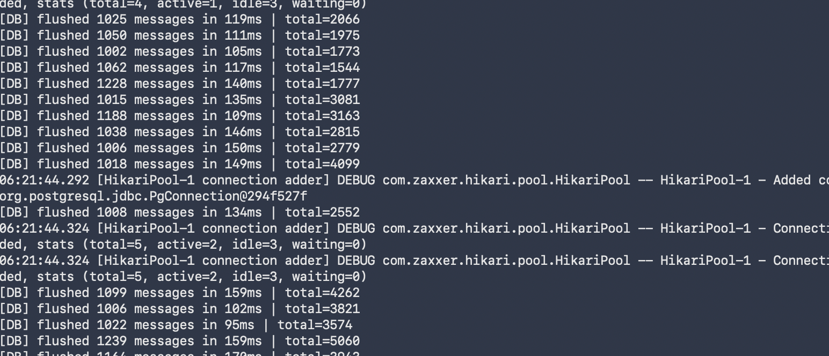

Batchsize 1000, flush interval 500ms, Test 4/4
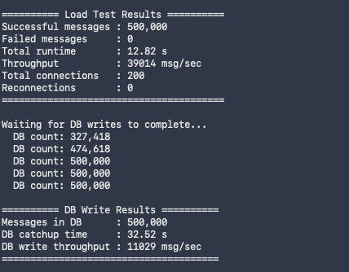
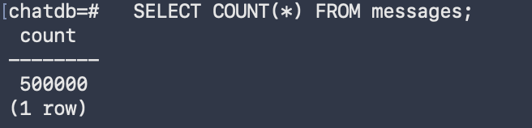
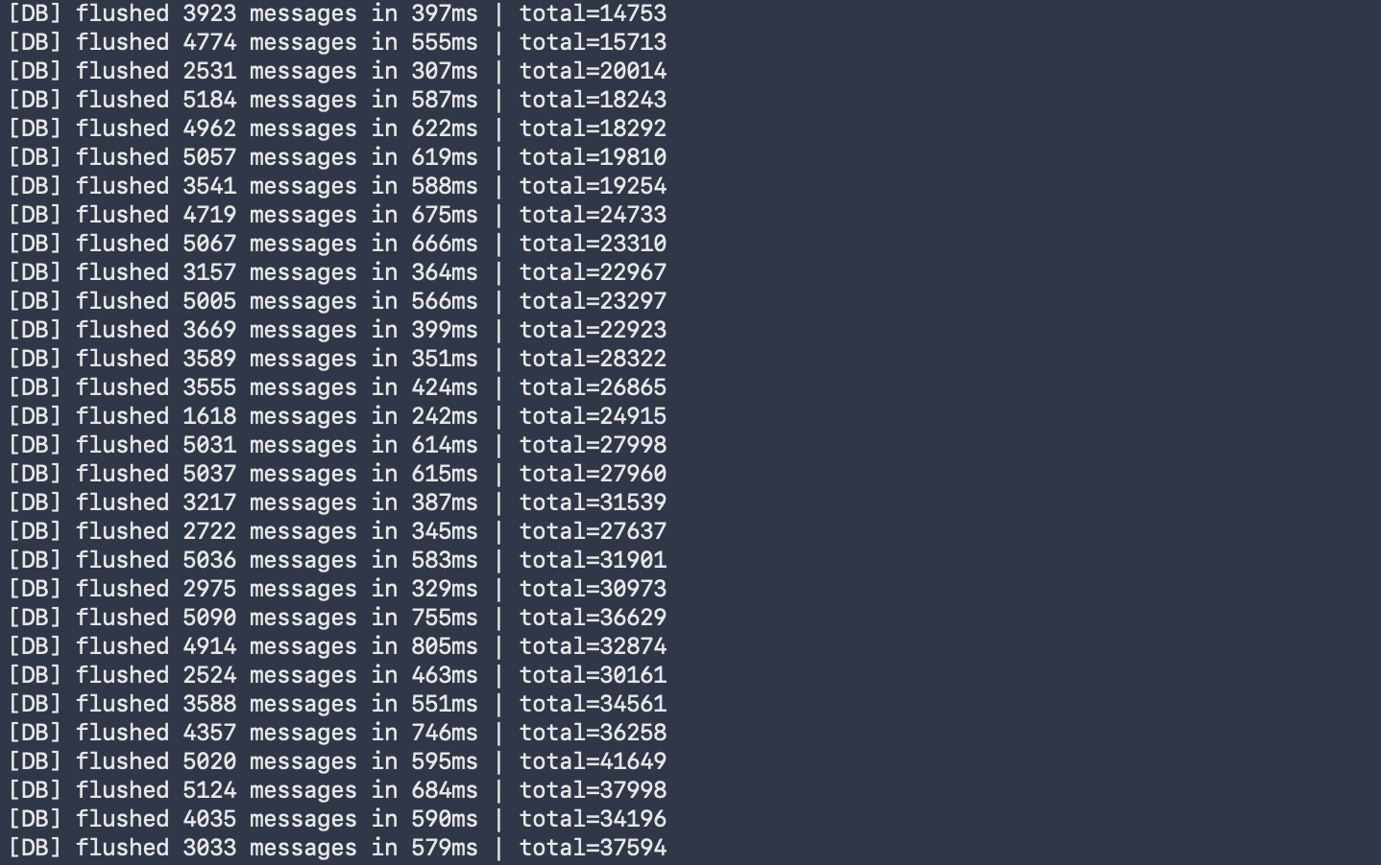

Summary:
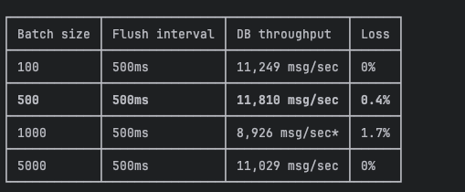
---We will go with 500 batch size for actual load testing---

- Actual Load tests with 500 batch size
-------------------------------------Test 1 Baseline-----------------------------------------
Write throughput:

Database CPU/memory:
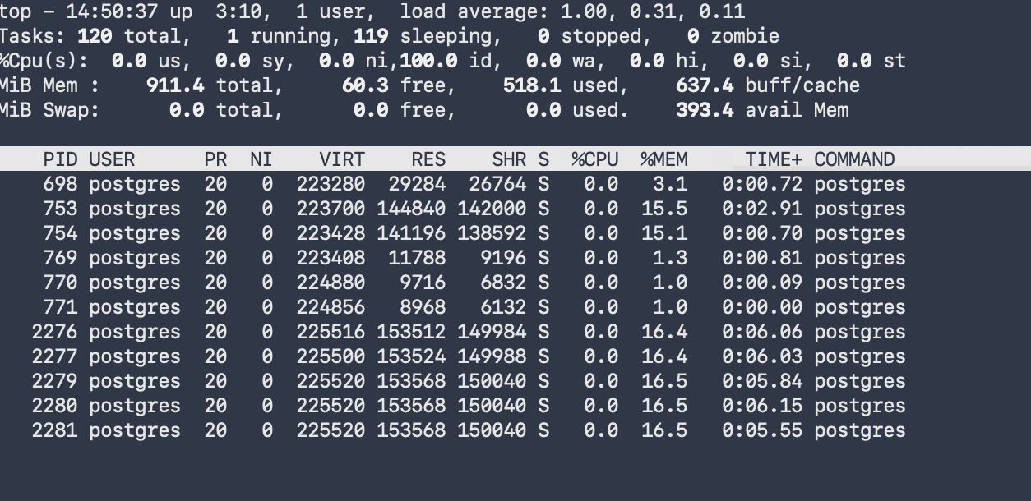
Queue depth stability:

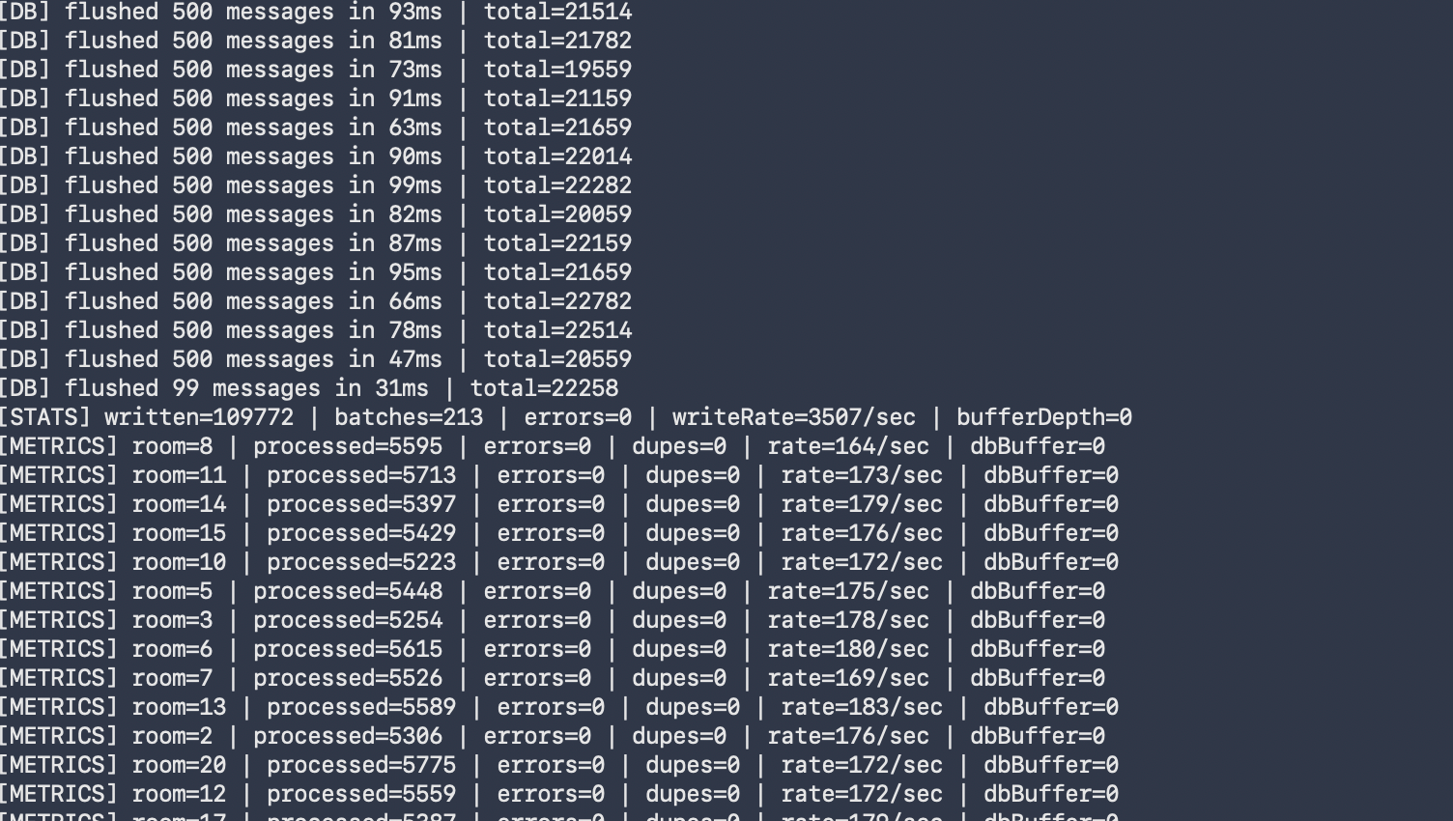
Metrics API output:
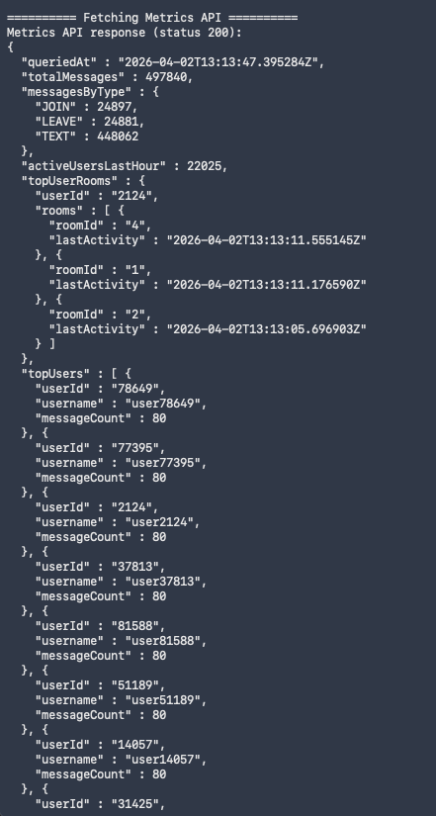
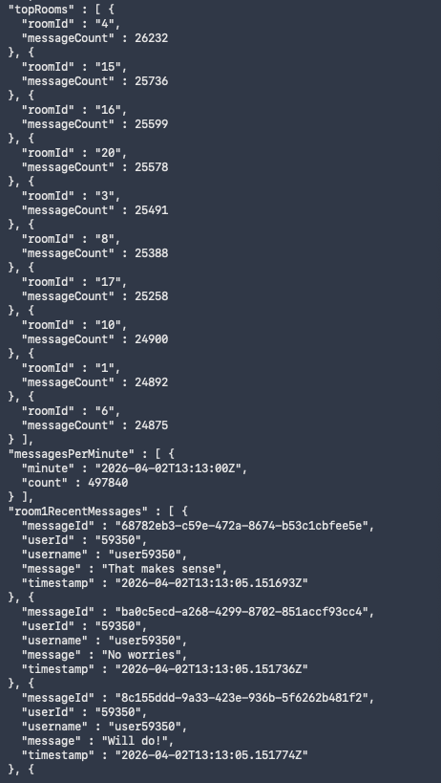
-------------------------------------Test 2 Stress Test-----------------------------------------
RabbitMQ crashed during running.
Bottleneck: RabbitMQ broker ran out of memory under sustained 1M message load on a
local machine. The broker crashed at ~200K messages queued, causing connection resets
to both the server and consumer.

Root cause: Running all components (server, consumer, RabbitMQ, client) on a single
laptop with limited RAM. In a production deployment, RabbitMQ would run on a dedicated
instance with memory limits and clustering.

-------------------------------------Test 3 Endurance Test-----------------------------------------
